***Skill – Design Patterns and Principles***

**Exercise 1: Implementing the Singleton Pattern**

**Purpose:-** **The Singleton Pattern ensures that a class has only one instance and provides a global point of access to it. It's commonly used for configuration managers, logging, or thread pools.**

**CODE:-**

**Logger.java:**

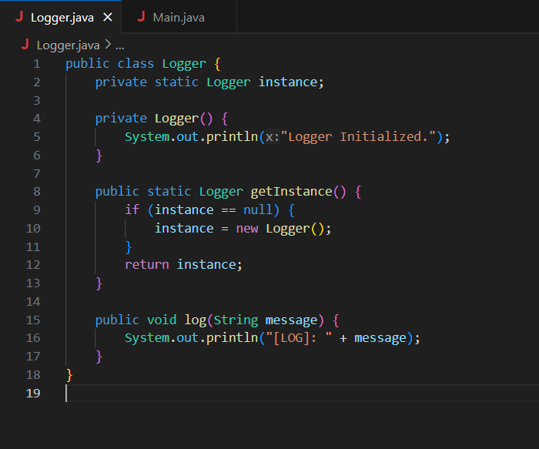

**Main.java:**

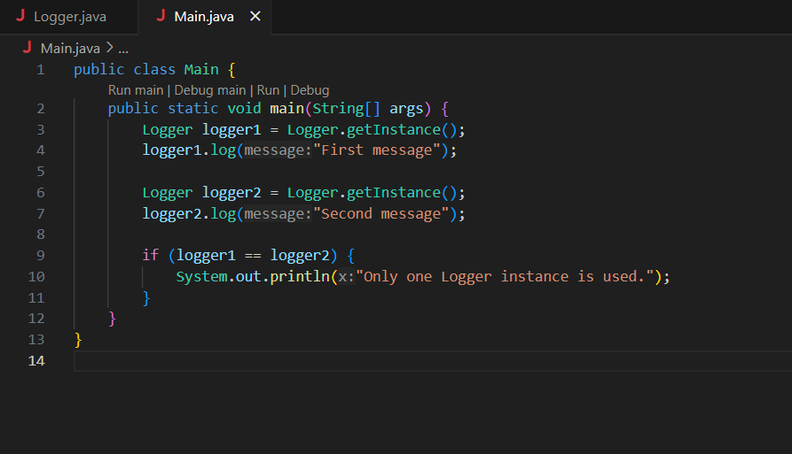

**Output:**

